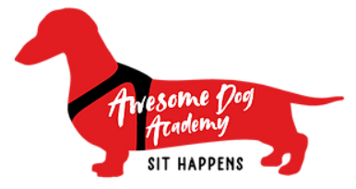

This recognizes that

Kid’s name
Is an awesome dog owner and has worked hard to train their dog.

You are a wonderful example of how everybody can have fun and enjoy the dog training experience. Keep up the good work!
Dog Trainer |  | Date

